BEER
slovníček: BEER – pivo, BREWERY - pivovar

Match the following beers to the countries of their origin from the chart:
Belgium the Netherlands England the Czech republic Denmark Mexico Ireland the United States of America
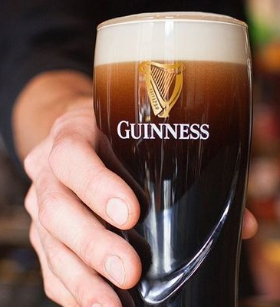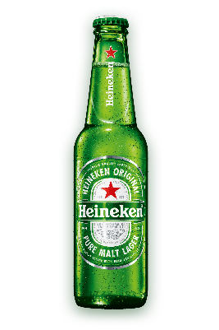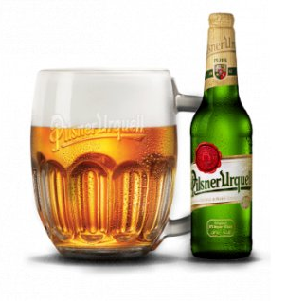
- ………………….. 2. …………… 3. ……………………… 4. …………
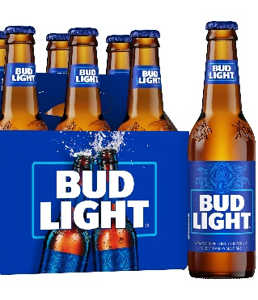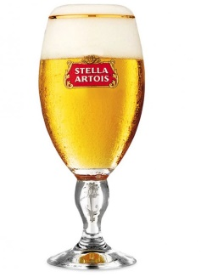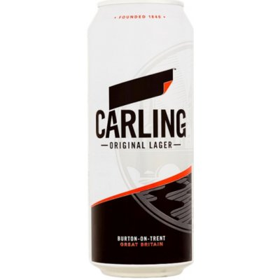
5. ………………………… 6 ……………………. 7. …………………… 8. ……………………

Match the following Czech breweries to cities in the Czech republic:
1. | Pilsner Urquel | A) | Humpolec
2. | Kozel | B) | Hanušovice
3. | Černá Hora | C) | České Budějovice
4. | Bernard | D) | Velké Popovice (central Bohemia)
5. | Starobrno | E) | Plzeň
6. | Holba | F) | Krušovice
7. | Budweiser Budvar | G) | Plzeň
8. | Gambrinus | H) | Velké Březno (Northern Bohemia)
9. | Krušovice | I) | Brno
10. | Březňák | J) | Černá Hora (near Brno, Southern Moravia)

There are 2 minor regional breweries, do you know how are they called?
In Zábřeh, regional brewery called …………………was founded recently.
In Velké Losiny, there is another regional brewery called ………………………….
Listening: Top 10 Best Global Beers https://www.youtube.com/watch?v=3_NSrlbu458
- your task is to write down names of the top 10 best global beers + countries of their origin
KEY – BEER:
- Guiness – Ireland
- Heineken – the Netherlands
- Pilsner Urquell – the Czech republice
- Corona – Mexico
- Bud Light – the USA
- Stella Artois – Belgium
- Carling – England
- Carlsberg – Denmark

Czech beer:
- E
- D
- J
- A
- I
- B
- C
- G
- F
- H

Regional breweries:
There are 2 minor regional breweries, do you know how are they called?
In Zábřeh, regional brewery called WELZL was founded recently.
In Velké Losiny, there is another regional brewery called ZLOSIN.

